Decision Tables — Practice Exercises
Oct 5, 2026
Five exercises, from easy (2 conditions) to harder (4 conditions). Solve each one following the same 7 steps as the worked example in class. The solutions are at the end of the document.

How to solve each exercise
- Read the statement and underline the conditions (Yes/No questions) and the actions (what the system does).
- Extract the conditions (C1, C2…) and the actions (A1, A2…).
- Build the binary table: with n conditions there are 2ⁿ rules. Fill the first row with blocks of half, the next with blocks of a quarter, and so on.
- Fill in the actions for each rule, reading every column as IF … AND … THEN …
- Simplify: two rules with the same actions that differ in only one condition merge into one, with a “–” in that condition.
- Check and order: the importances of the simplified rules must add up to 2ⁿ. Ask first about the condition with the highest importance.
- Draw the flowchart: one path per simplified rule.

Exercise 1 — Cinema tickets (easy · 2 conditions)
A cinema applies the following pricing rules. Students get a 20% discount. On Wednesdays (“cinema day”) every customer gets a 30% discount. Discounts are never added together: a student who goes on a Wednesday gets only the 30% discount. Any other customer pays the normal price.
Build the decision table, simplify it and draw the flowchart.
Hint: the statement talks about students first, but is that the best question to ask first?

Conditios | r1 | r2 | r3 | r4
Is it a student? | Y | Y | N | N
Cinema day | Y | N | Y | N
20% |  | X
30% | X |  | X
0% |  |  |  | X

 | 2^1 = 2 | 2^0=1 | 2^0=1
STUDENT | _ | Y | N | 2
WEDNESDAY | Y | N | N | 4
20% |  | X
30% | X
0% |  |  | X

WEDNESDAY | Y | N | N
STUDENT | _ | Y | N
20% |  | X
30% | X
0% |  |  | X
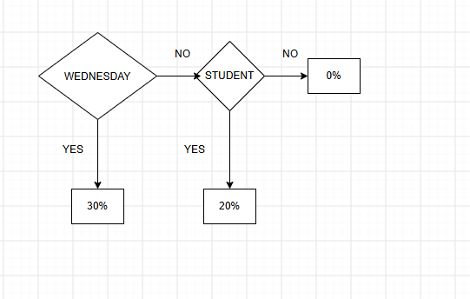

Exercise 2 — App login (easy · 2 conditions)
A mobile app checks every login attempt. If the username exists and the password is correct, access is granted. If the username exists but the password is wrong, the message “Wrong password” is shown and the failed-attempts counter is increased by one. If the username does not exist, the message “User not found” is shown.
Build the decision table, simplify it and draw the flowchart.
Hint: one rule triggers two actions at the same time.
USERNAME | Y | Y | N | N
PASSWORD | Y | N | Y | N
ACCESS GRANTED | X
WRONG PASSWORD |  | X
USER NOT FOUND |  |  | X | X
INCREASE COUNTER BY 1 |  | X

Simplify
Las 2 ultimas reglas tienen las mismas acciones y solo se diferencian en 1 condicion por lo tanto se pueden simplificar

 | 2^0=1 | 2^0=1 | 2^1=2
USERNAME | Y | Y | N | 4
PASSWORD | Y | N | _ | 2
ACCESS GRANTED | X
WRONG PASSWORD |  | X
USER NOT FOUND |  |  | X
COUNTER + 1 |  | X

Order
USERNAME | N | Y | Y
PASSWORD | _ | Y | N
ACCESS GRANTED |  | X
WRONG PASSWORD |  |  | X
USER NOT FOUND | X
COUNTER + 1 |  |  | X

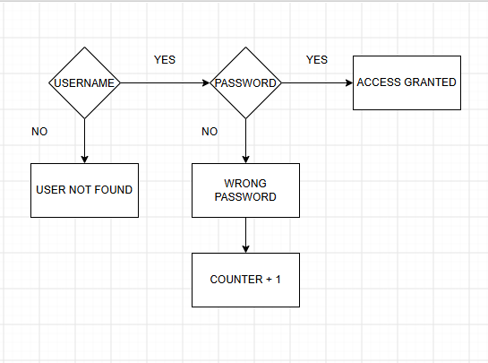

Exercise 3 — Online shop shipping (medium · 3 conditions)
An online shop decides how to handle each order. If the product is out of stock, the order is not shipped yet: the customer receives a “Shipping delayed” email and nothing else is calculated. If the product is in stock, Premium customers always get free shipping. Customers who are not Premium get free shipping only when the order is over €50; otherwise a shipping fee of €4.99 is charged.
Build the decision table, simplify it and draw the flowchart.
Hint: the same action can appear at the end of more than one path.
C(CONDITIONS)1 | STOCK | Y | Y | Y | Y | N | N | N | N
C2 | PREMIUM | Y | Y | N | N | Y | Y | N | N
C3 | >$50 | Y | N | Y | N | Y | N | Y | N
A(CTIONS)1 | NOT SHIPPED
A2 | SHIPPING DELAYED EMAIL |  |  |  |  | X | X | X | X
A3 | FREE SHIPPING | X | X | X
A4 | SHIPPING FEE $4,99 |  |  |  | X

Simplify

COLUMNS | 1-2 | 2 | 4 | 5-6 | 7-8
C1 | Y | Y | Y | N | N
C2 | Y | N | N | Y | N
C3 | _ | Y | N | _ | _
DELAYED |  |  |  | X | X
FREE | X | X
$4,99 |  |  | X
RULE IMPORTANCE | 2^1=2 | 2^0=1 | 2^0=1 | 2^2=4 | CONDITION IMPORTANCE
COLUMNS | 1-2 | 2 | 4 | 5-8
C1 | Y | Y | Y | N | 8
C2 | Y | N | N | _ | 4
C3 | _ | Y | N | _ | 2
DELAYED |  |  |  | X
FREE | X | X
$4,99 |  |  | X

 | 7-8 | 1-2 | 3 | 4
C1 | N | Y | Y | Y
C2 | _ | Y | N | N
C3 | _ | _ | Y | N
 | X
 |  | X | X
 |  |  |  | X

Exercise 4 — Study grants (medium · 3 conditions)
A school awards study grants. Students with an average mark of 8 or more always get the grant. Students with an average below 8 also get it when their family income is low and they have no failed subjects. Students with a low family income who do not get the grant are offered a payment plan instead. All other applications are rejected.
Build the decision table, simplify it and draw the flowchart.
Hint: “always” in a statement usually means that the other conditions do not matter for that case.

Exercise 5 — Smart home alarm (harder · 4 conditions)
A smart home alarm decides what to do every time it checks the house. If the alarm is not armed, it does nothing. If it is armed but no door has been opened, it also does nothing. If it is armed and a door is opened, the system waits 30 seconds for the security code:
- If the correct code is entered, the alarm is disarmed. In addition, if the owner's phone is not at home, a notification is sent to the phone (“Alarm disarmed while you are away”).
- If the correct code is not entered, a notification is always sent to the owner's phone and, if the owner's phone is not at home, the siren also sounds.
Build the decision table, simplify it and draw the flowchart.
Hint: with 4 conditions you need 2⁴ = 16 rules. Look for a block of 8 rules that collapses into a single one.

Solutions
Y = Yes, N = No, – = indifference (the condition does not matter), X = the action is executed.

